# 5th lecture

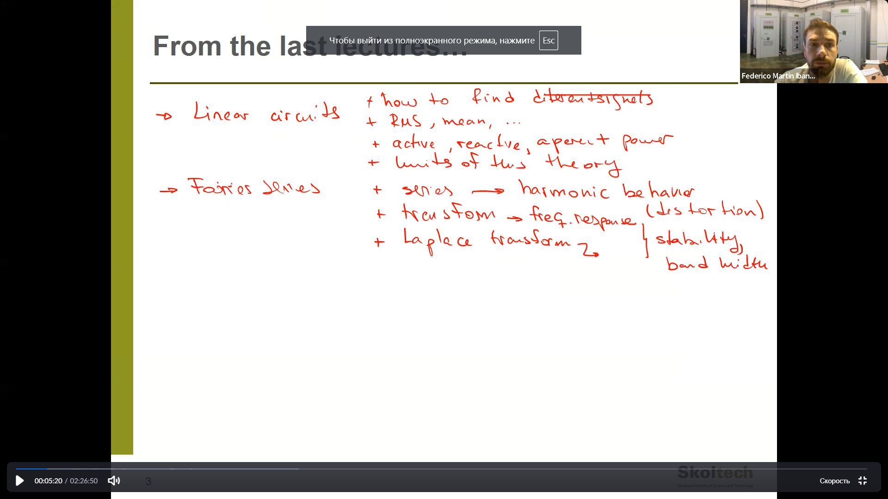

1. 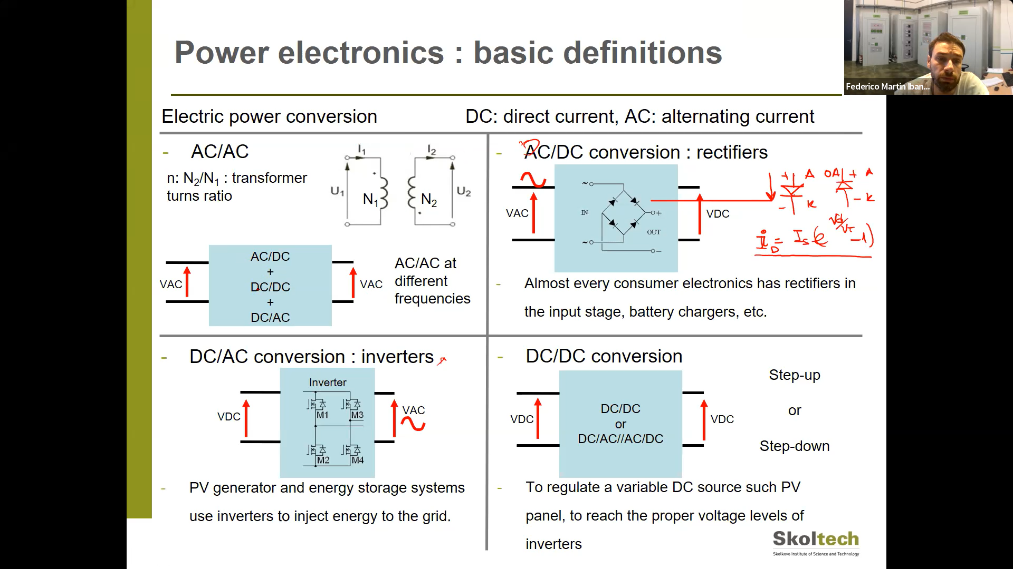
2. 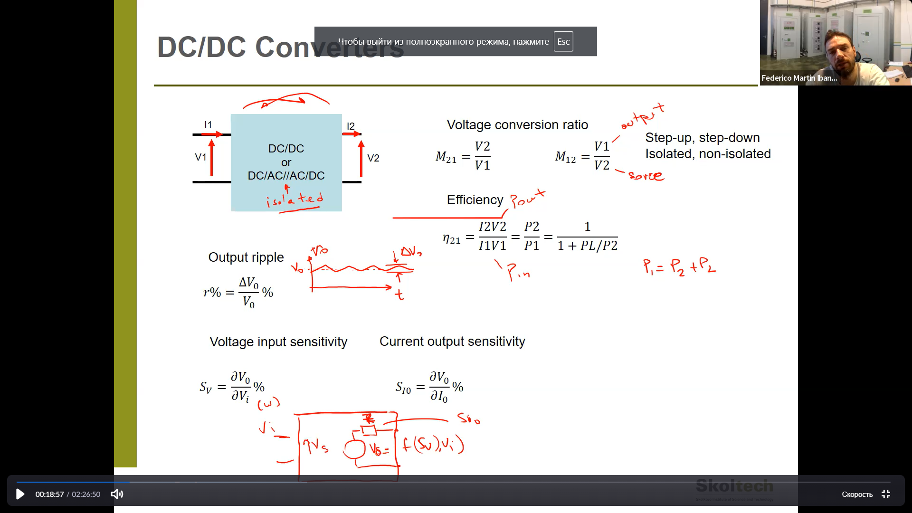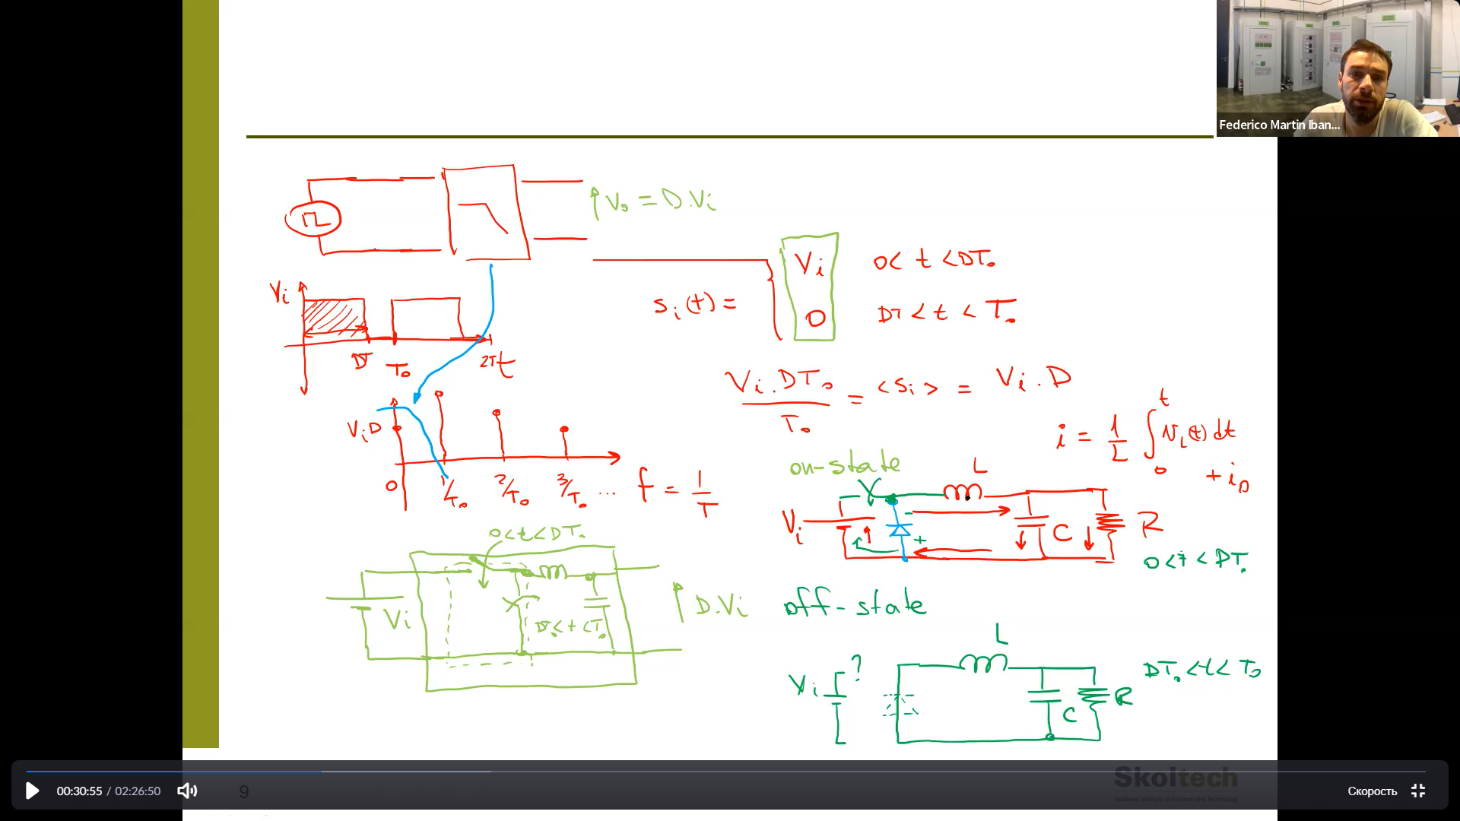
3. Buck converter.

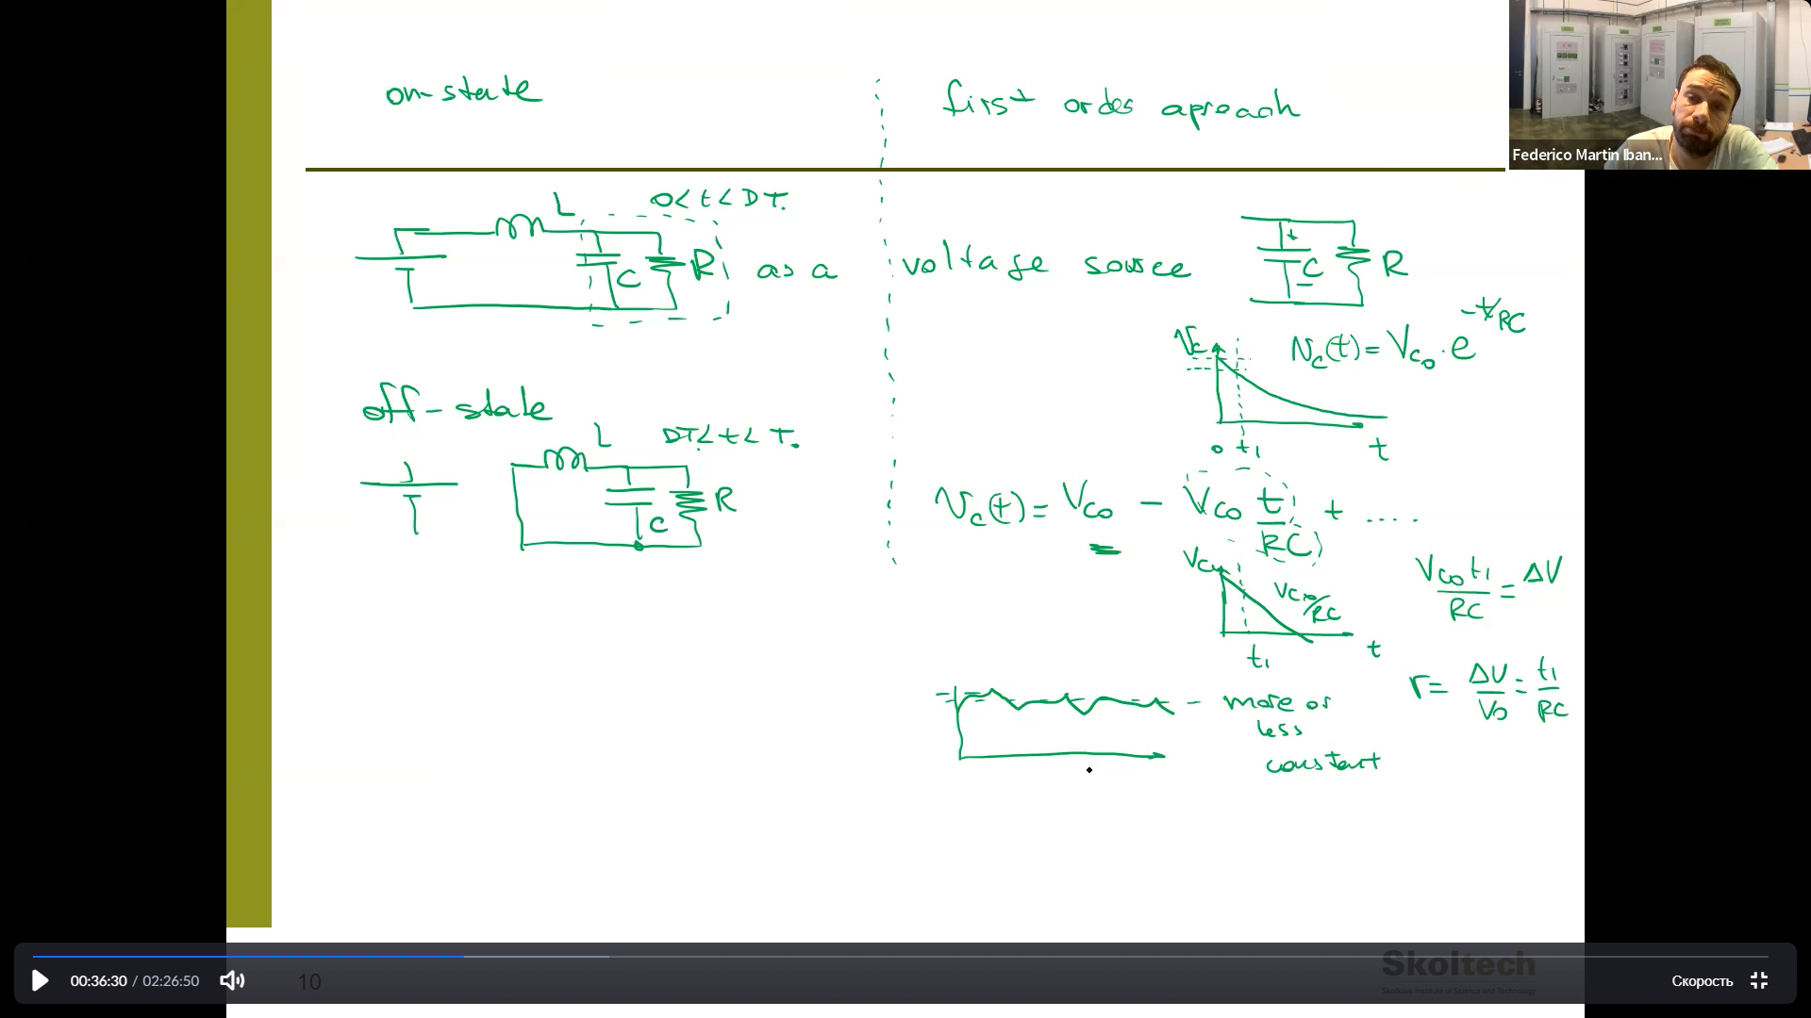

Consider voltage of capacitor as constant? (in terms of short charging time)

1. Find the current of the inductor.

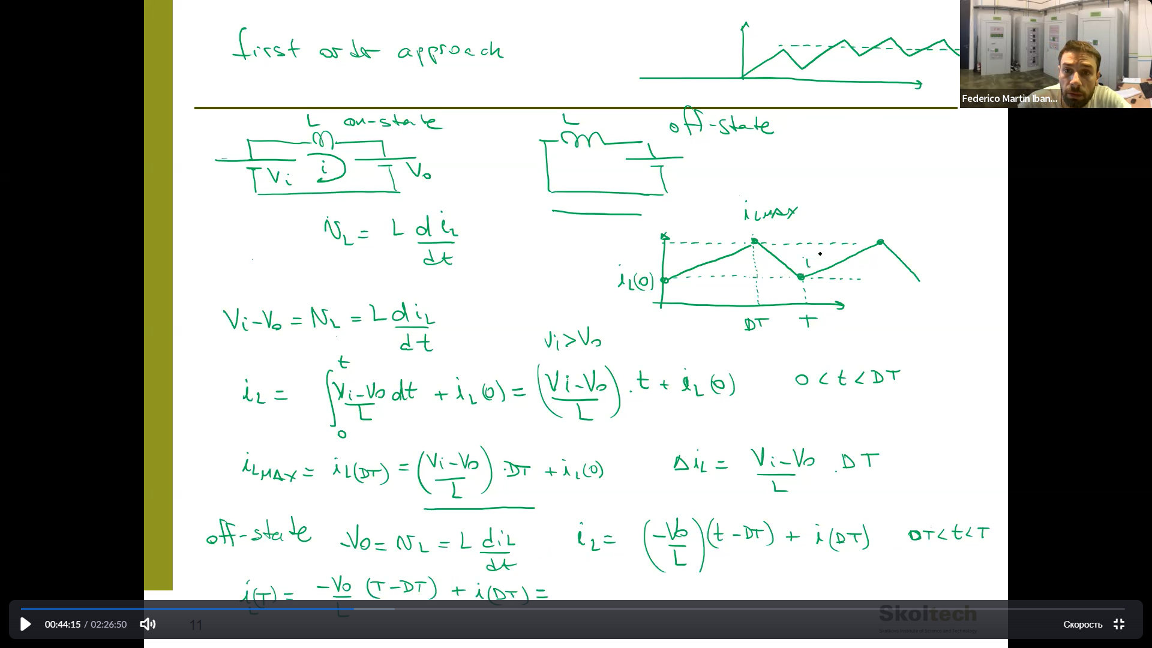

1. Now, firstly we connect our solutions on the period, as result found, that D =… - we figured out V_0 – voltage of the capacitor.

Then represent current on constant and alternating parts. Ideally, the constant part goes through the resistor, alternating through the capacitor. 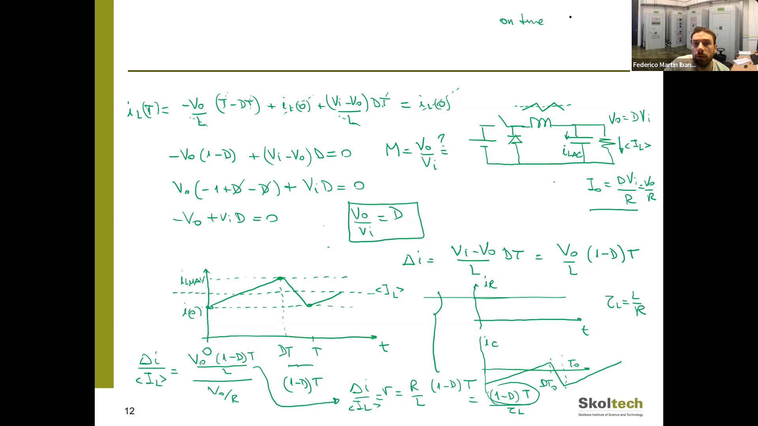

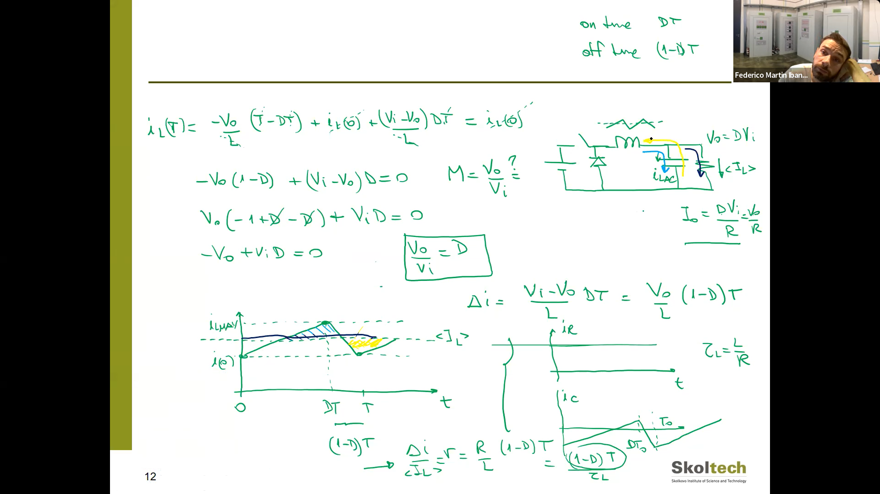

Then we estimate the ripple of capacitor voltage.

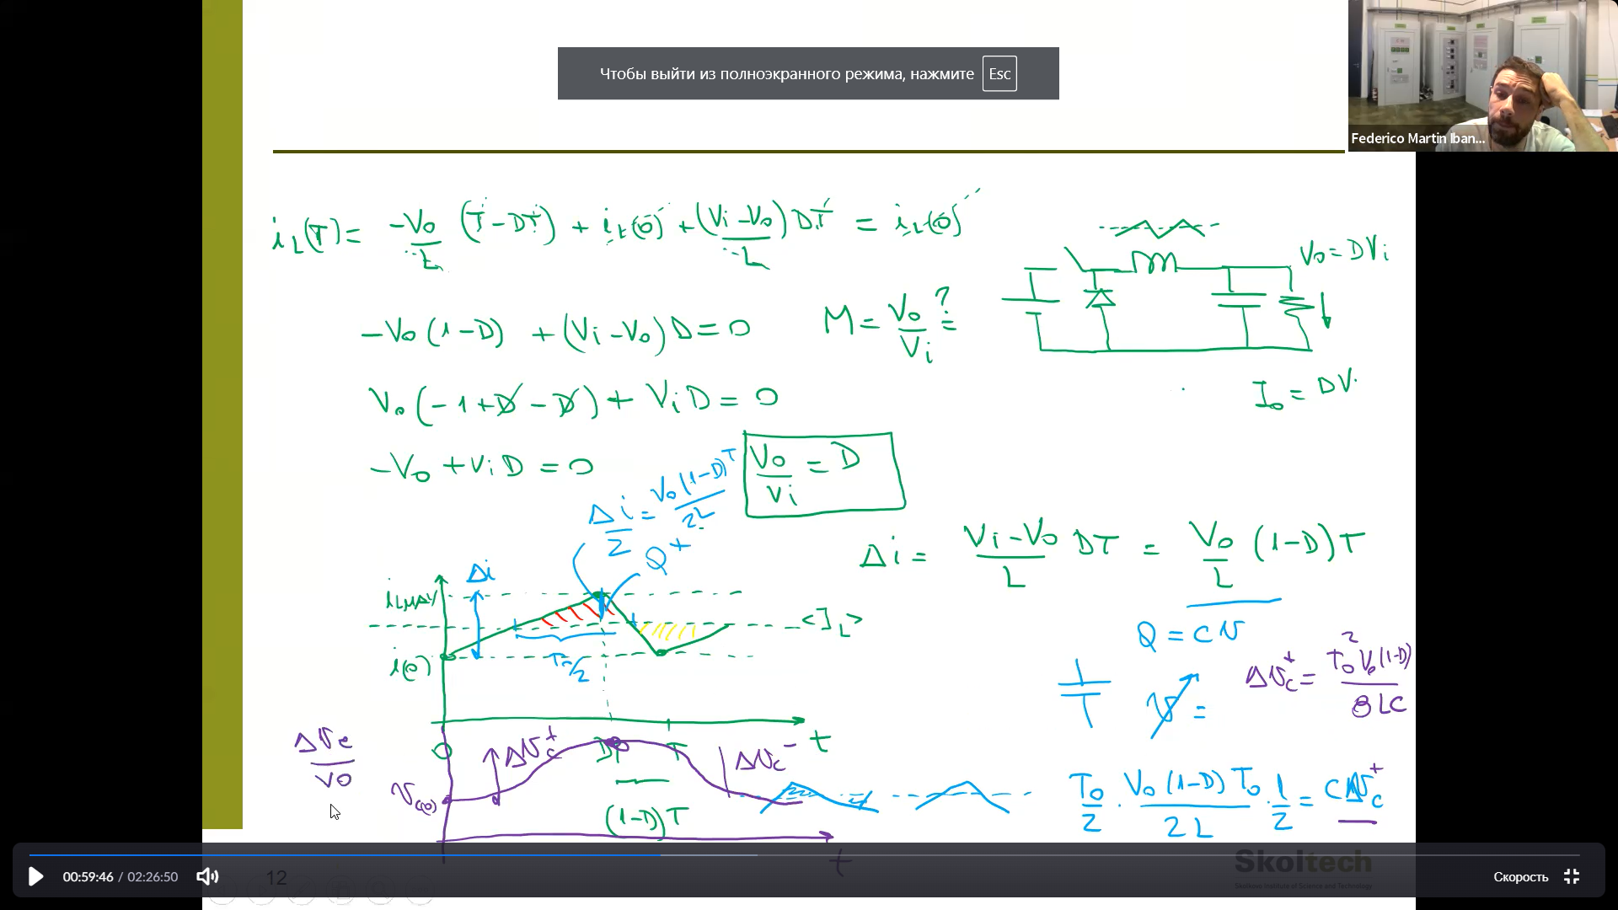

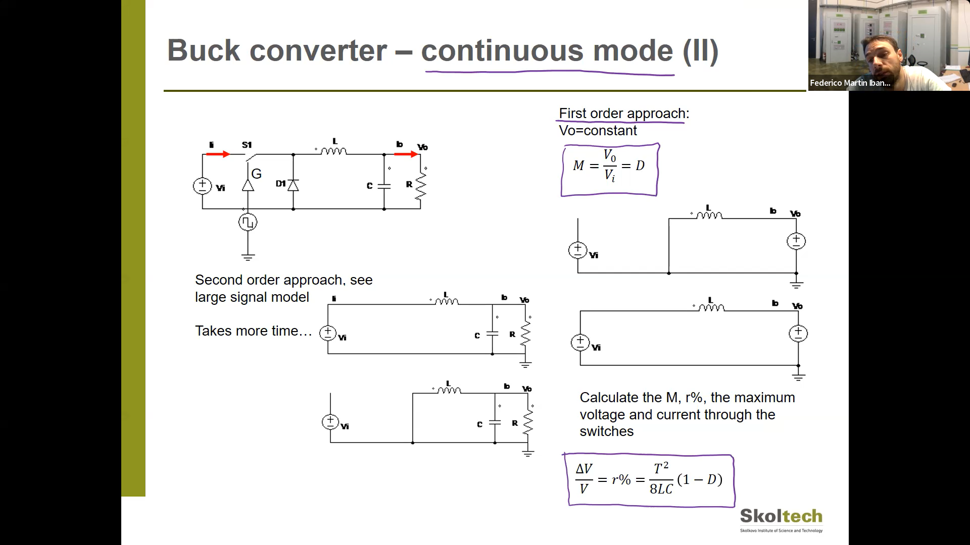

1. It may happen capacitor charge is over. In this way, the inductor would create a current in opposite direction but diode blocks. So there is a third state – a disconnected state.

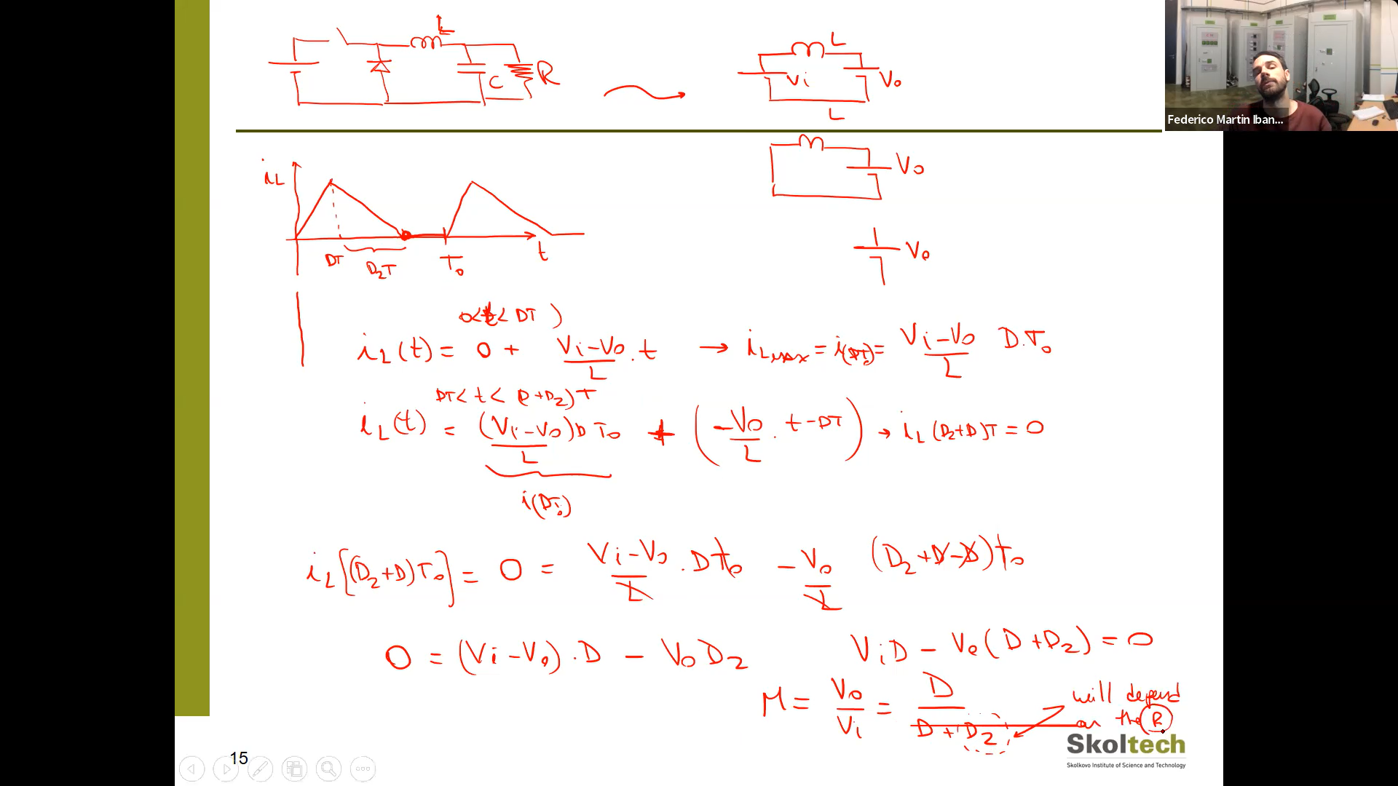

All the same, but V0/Vi ratio is different. D2 – depends on f(R).

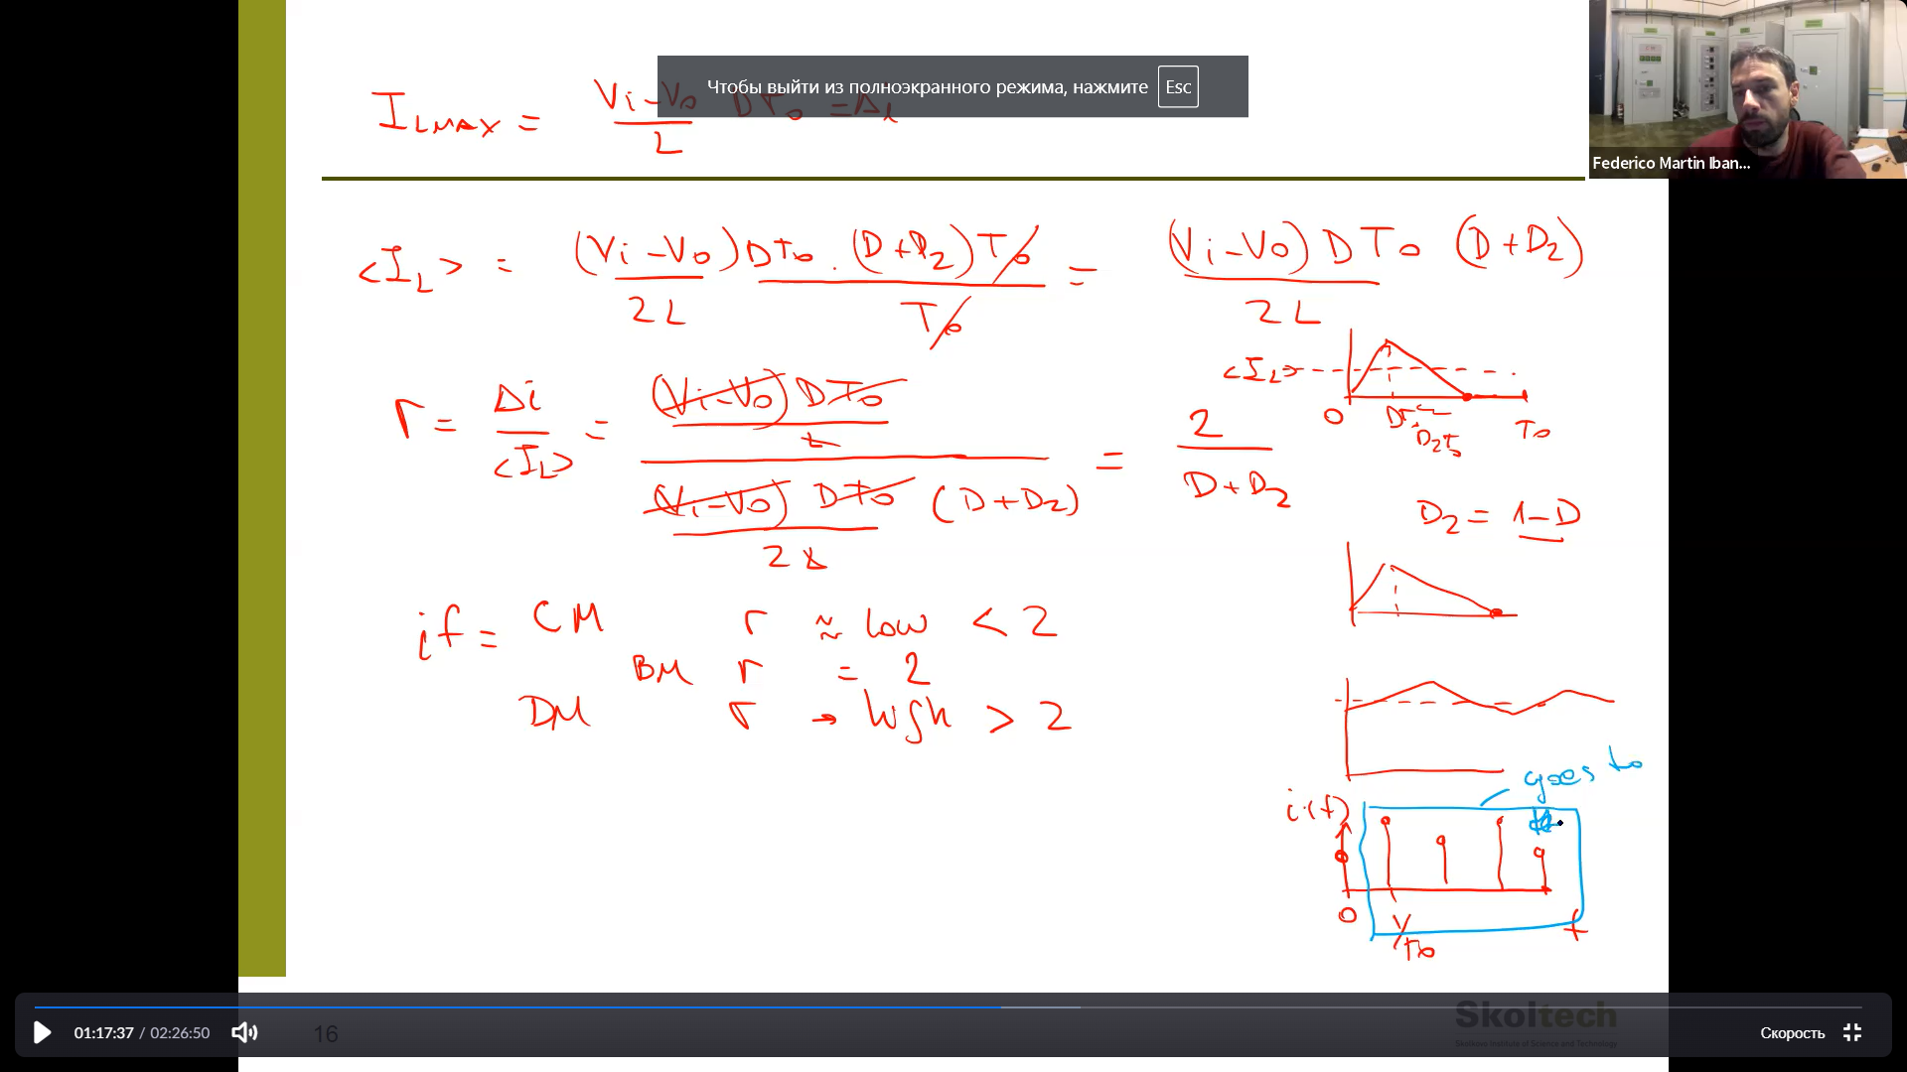

In the case of continuous mode, ripple is low

In the case of discontinuous mode, ripple is high.

If the ripple is high then most harmonics of I go through the capacitor.

So you need a big capacitor to avoid DM.

1. When we reduce the power we meet DM.

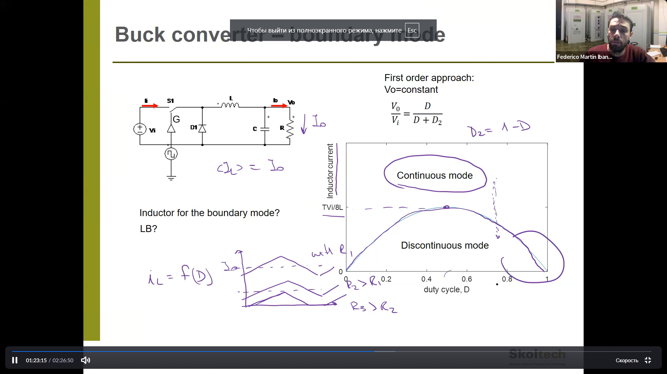

1. Do all the same, but for the next circuit (boost converter):

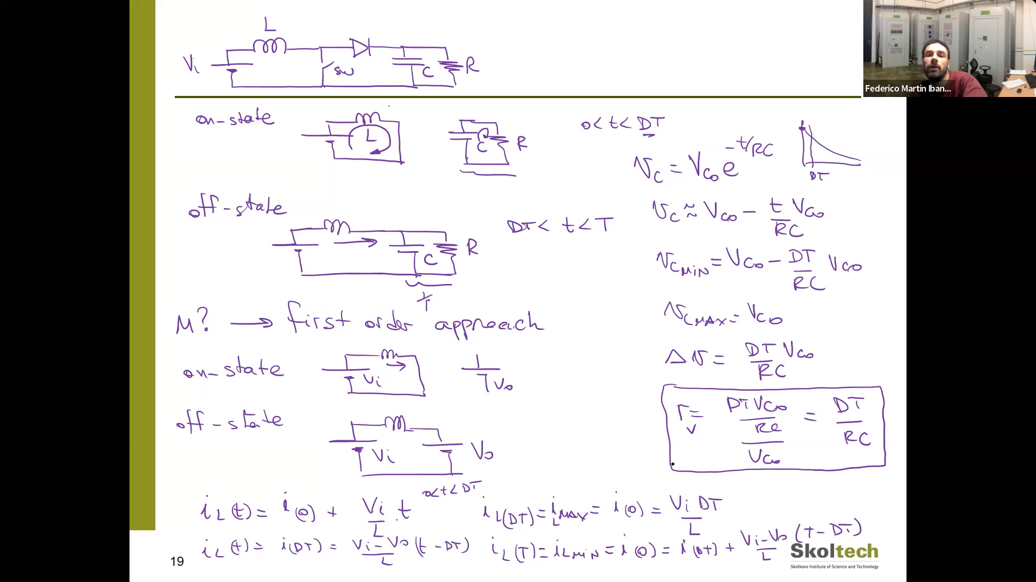

Find M ration between V0 and Vi. And plot them.

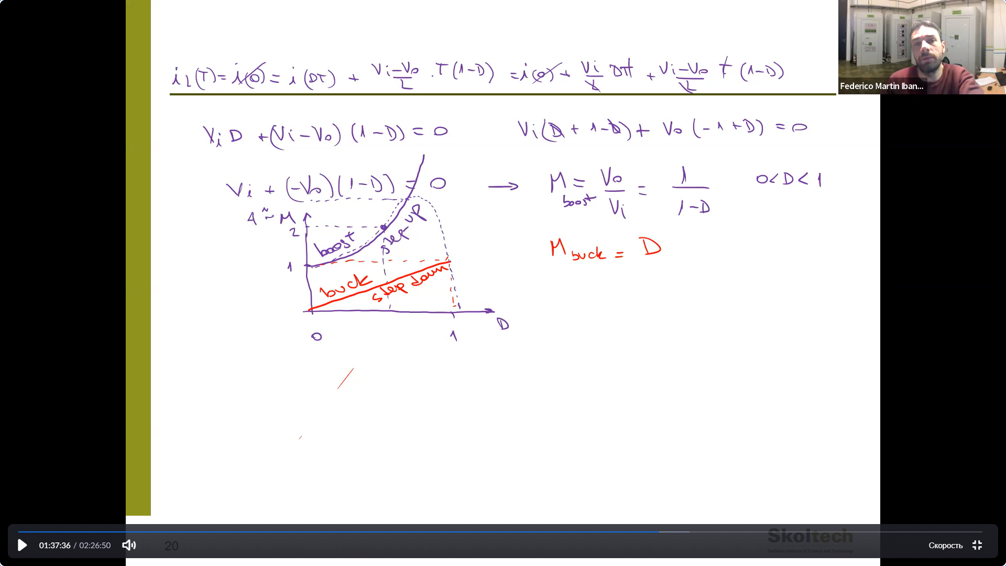

As far as I understand in on mode we create a large current, (Vt/L - large) after that connect the resistor – it decreases the current, but the inductor tries to stay current the same and supports creating additional voltage. So, the voltage on the capacitor will be more than on Vi.

1. Discontinuous mode:

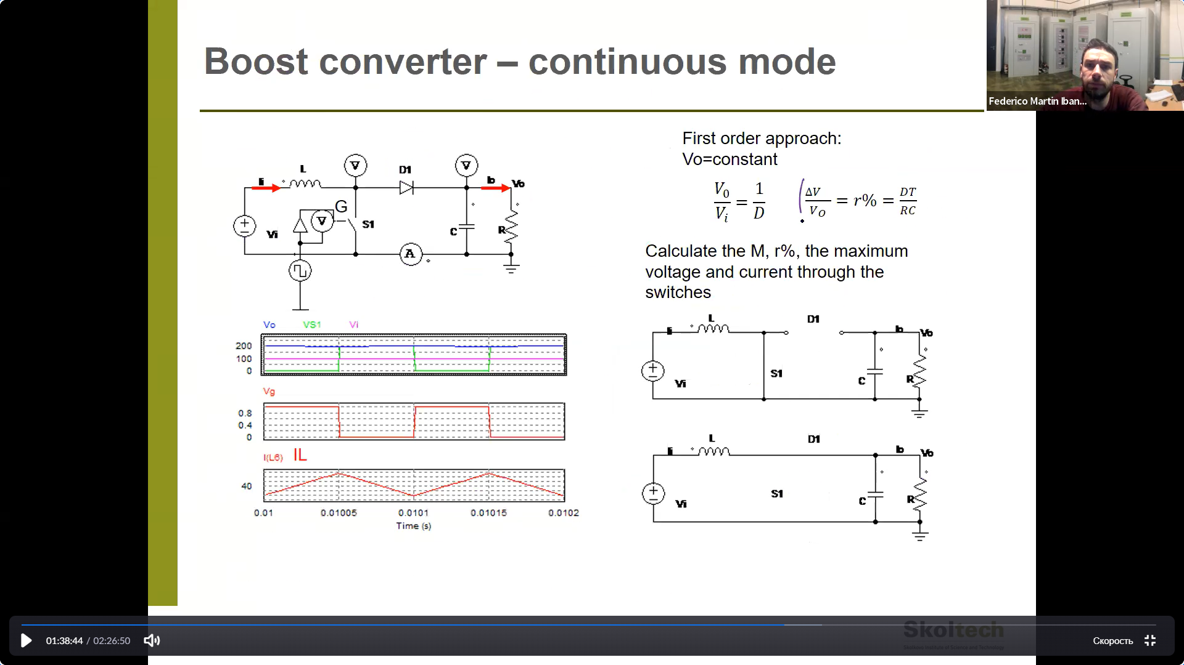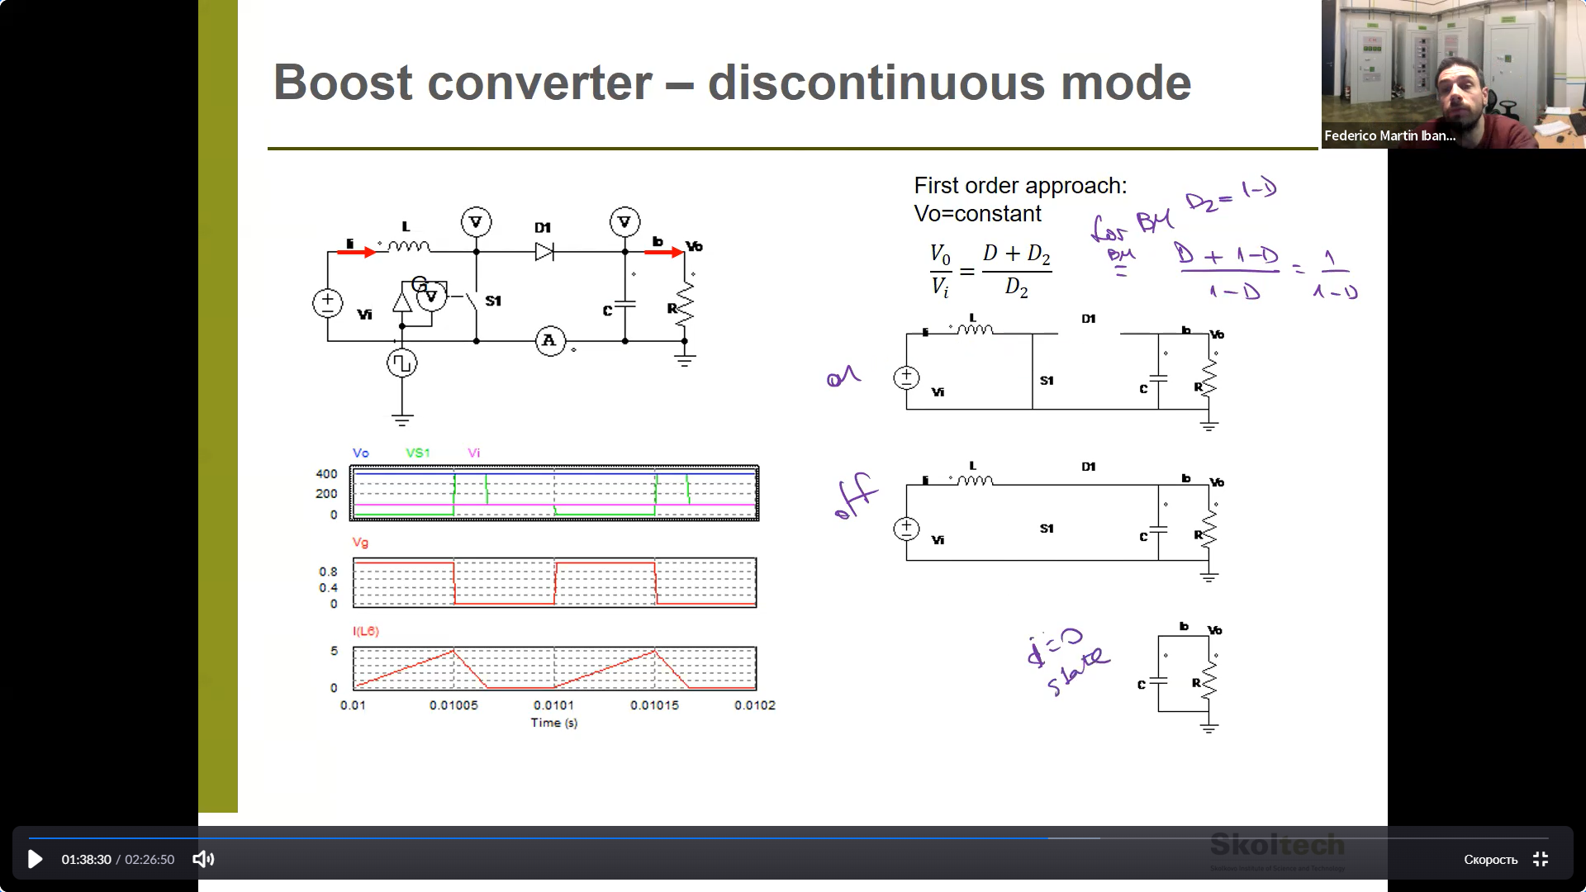

1. CM
2. HW

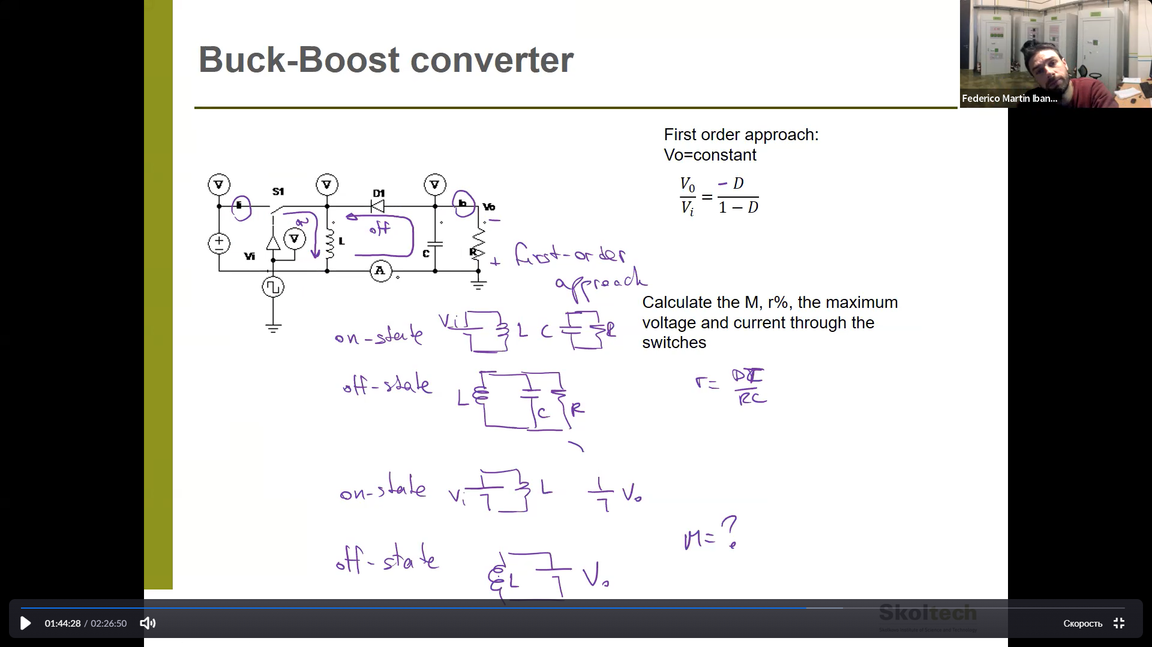

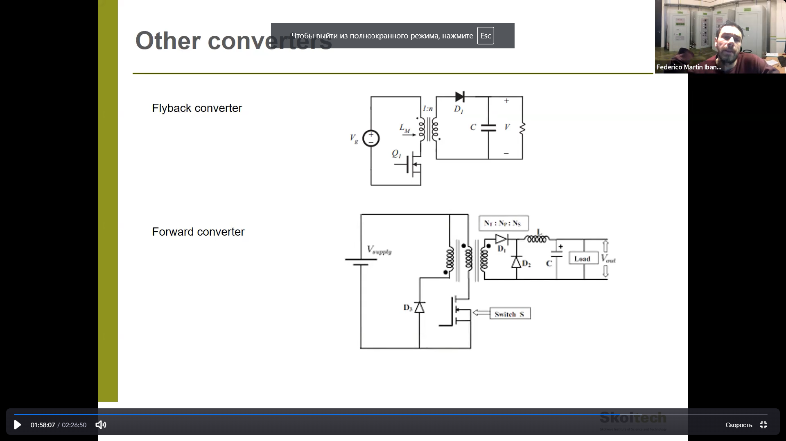

1. More about Flyback – is equivalent to Buck-boost converter.

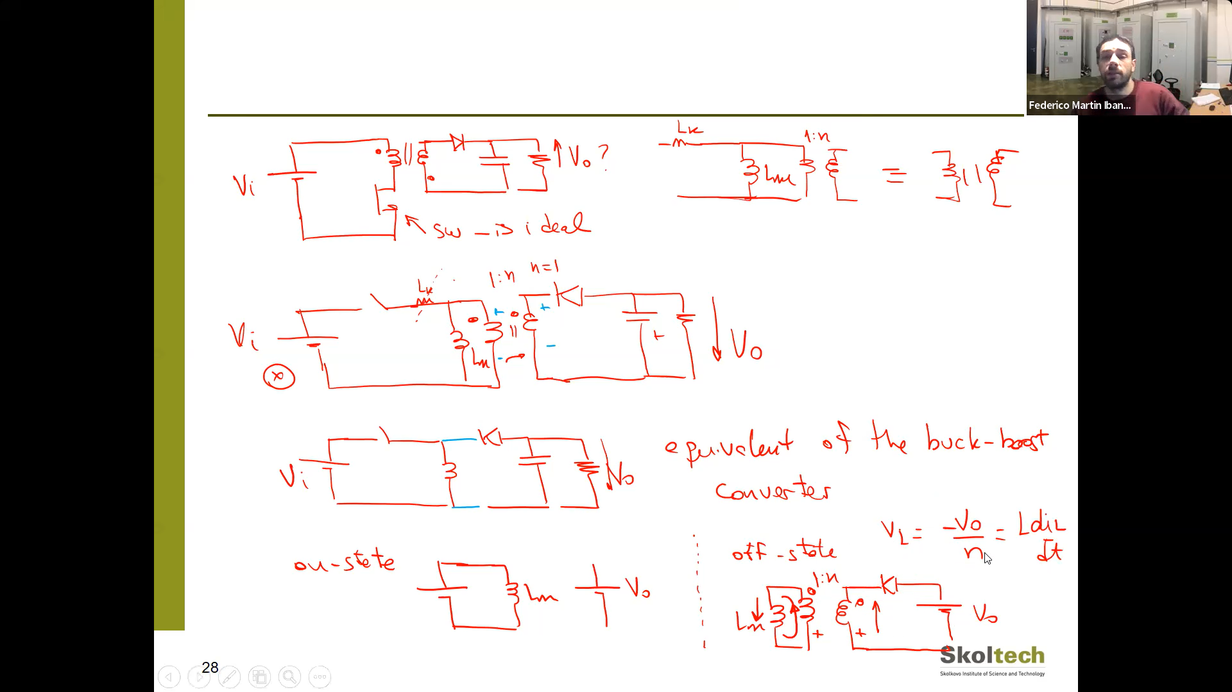

1. In practice we have Leakage inductance ( is green inductance) and Cp(parasitic capacitor on the switch).

On switch-off state, there is an oscillatory circuit – resonant effect.

Which creates high voltage and current – that may destroy the switch.

To avoid this you may add RC circuits in parallel to switch or diode – this damps the oscillations. But Resistor dissipates energy – this is a problem.

Lm is Magnetizing inductance.

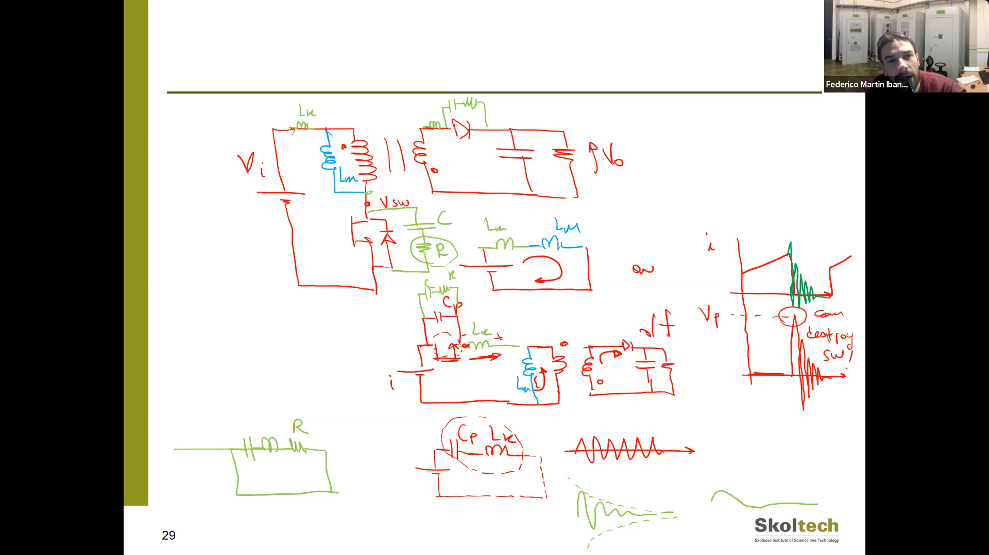

1. This is a Forward converter, the isolated part equals to buck converter.

Because of Lm (Magnetizing inductance), we have a current that creates a switch-off voltage on the output part of the converter, so it makes a buck converter on the right side. To avoid this we can add a blue circuit.

1. 